Lab 4

Q1)

1. 14
2. 5
3. Yes =9 No= 5
4. Outlook as it visualizes the data more clearly.
5. 11

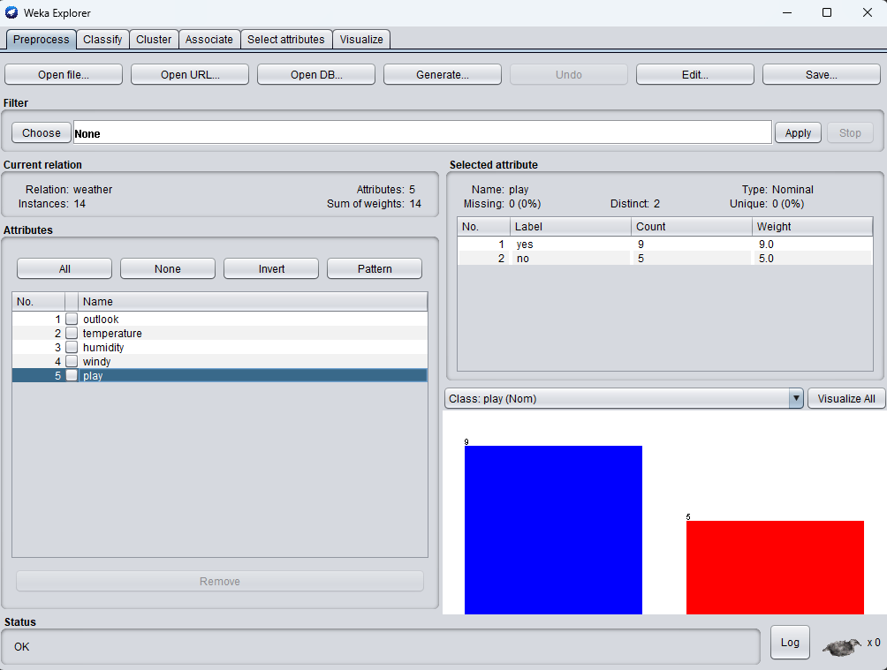

Q2)

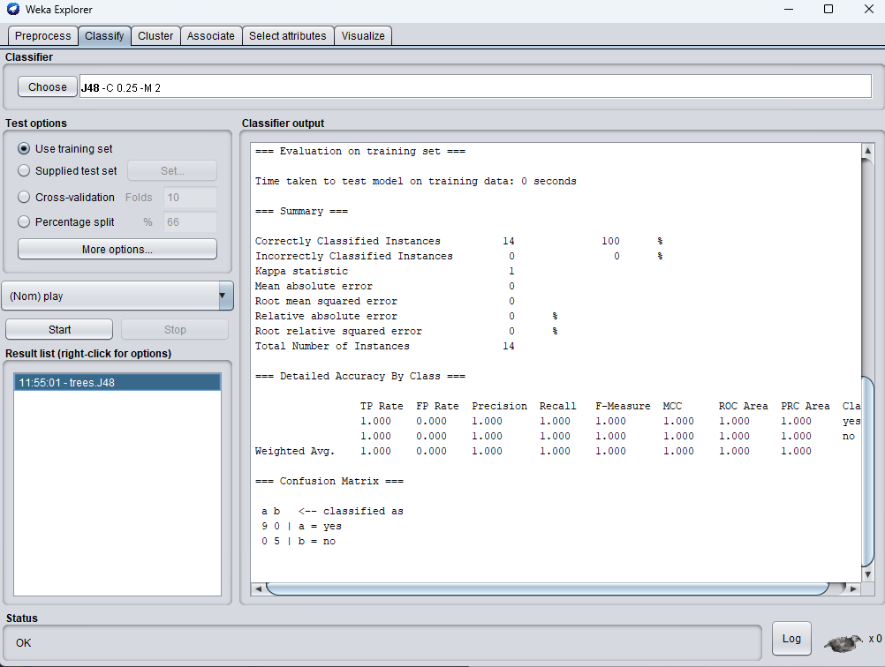

Visualizing the tree

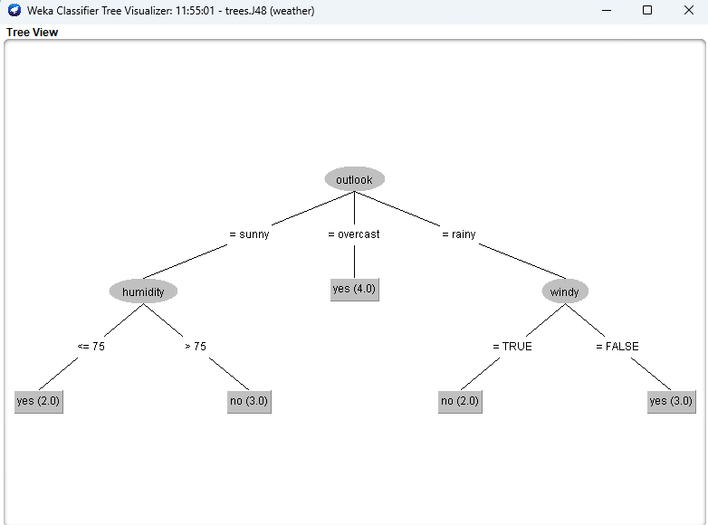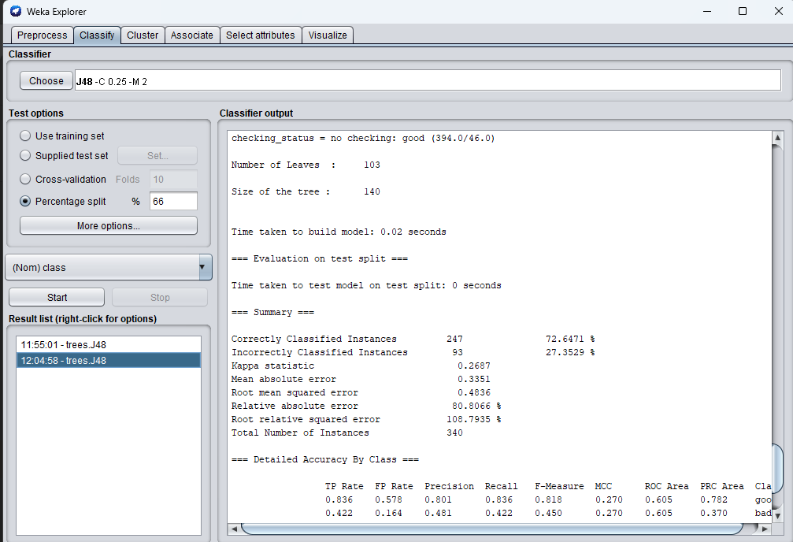

J48 classification defines the confusion matrix more precisely.

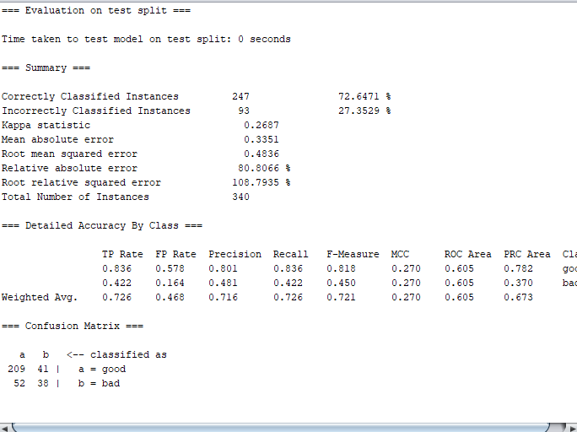

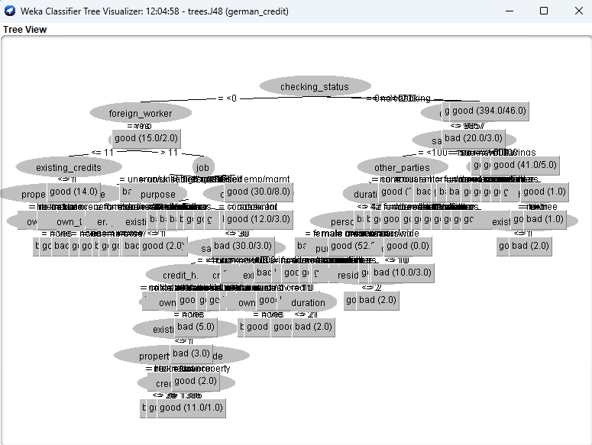

zeroR

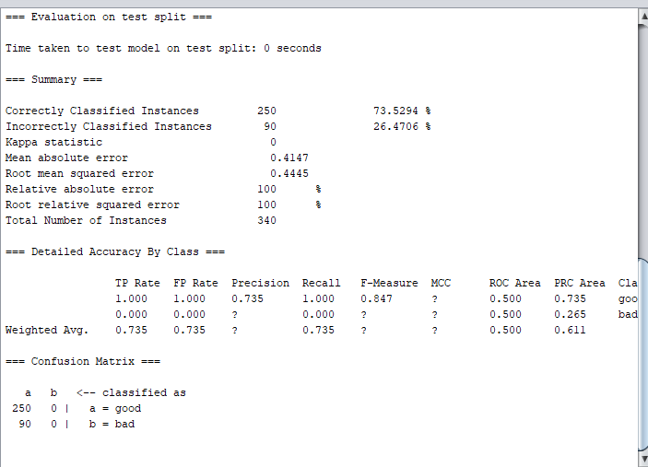

J48 better defines the good bad ratio

As we can see in J48 the good and bad in classes are defined separately.

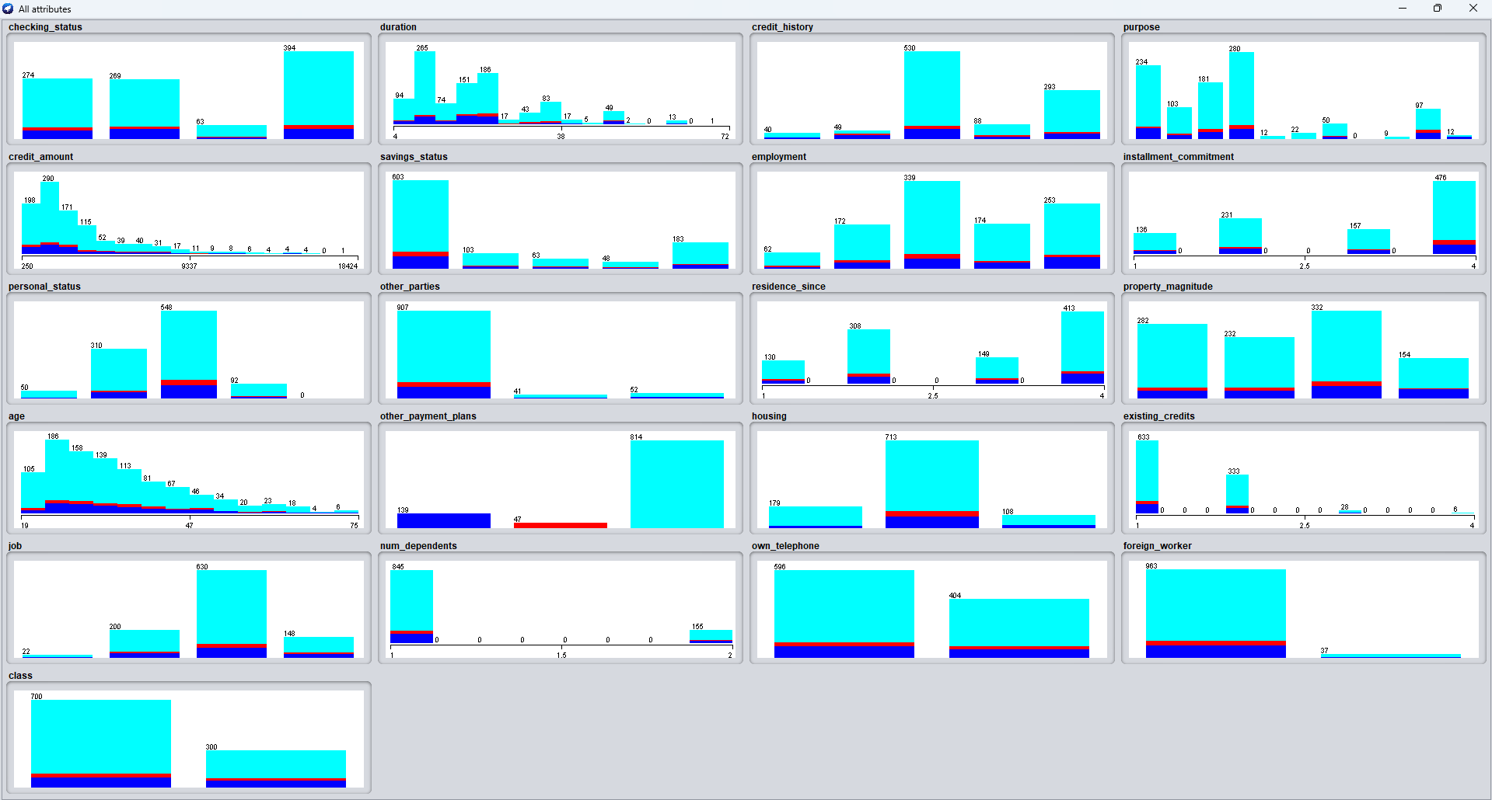

By visualizing all the attributes we can see that telephone is not relevant

There is a class imbalance where the good are 700 and bad are 300 in the data of 1000.